HARVEY AND DOROTHY FIRESTONE

Introduction

This is an attempt to put in writing what we remember and can find out about our parents, Harvey and Dorothy Firestone. I am starting to write on November 13, 2020, one year to the day after Harvey died. Dorothy died in 2004. It would have been better to write this 20 or 30 years ago, when we could have asked our parents to fill in the gaps in our knowledge, but we were busy raising our own families.

Early Years and Family Background

Harvey

Elliott Harvey Firestone was born on September 12, 1922, in Montreal, Quebec, Canada. His mother, Frieda Dora (Cohen) Firestone, was born in Manchester England to Romanian Jewish parents and her family moved to Montreal 1909 when she was 14 or 15 years old. Harvey's father was born Max Feuerstein in Koln, Germany, to a Romanian Jewish father and a German Jewish mother. Max immigrated to Montreal in 1910 as a 16-year old, and the rest of his family joined him a couple of years later.

Max and Dora were married in Montreal on June 20, 1920. They had four children, Rachel, Harvey, Jack and Roslyn, in that order. All were born at home, the three oldest at their home on St. Dominique Street, and Roz at their home on Jeanne Mance Street. Dr. Tom McCaffery was the doctor who delivered Harvey.

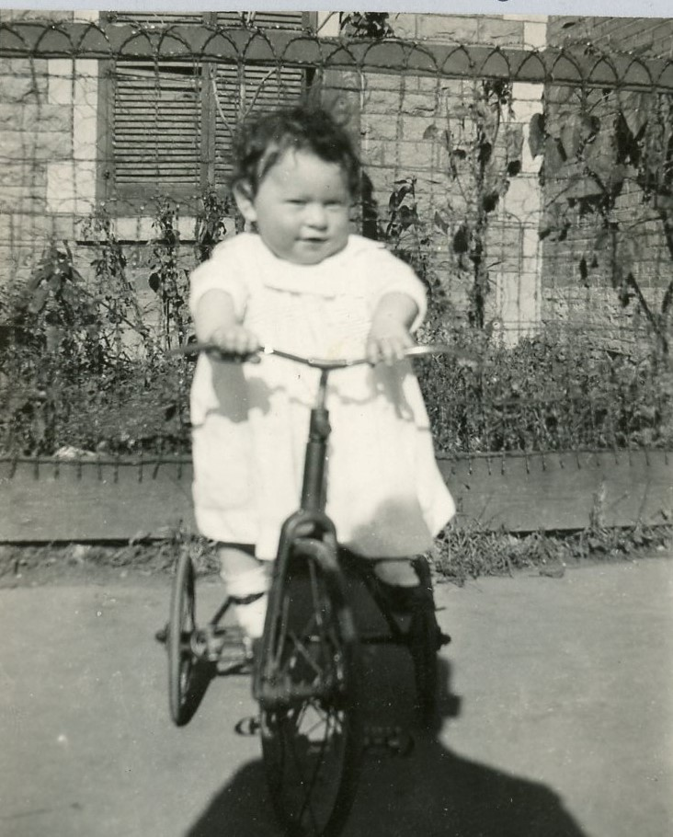
Harvey at 9 Months

Harvey was sick with asthma as a child. He spent much of the first seven years of his life in a hospital and did not attend school during that time. He did learn from the nurses in the hospital. He enrolled in kindergarden just before his fifth birthday, but soon spent a substantial amount of time in hospital and when he was finally able to attend school at age 7, he started in Grade 3.

The homes Harvey lived in as a child were rented flats. Montreal has a lot of two- and three-story attached housing, with all houses on the block creating a contiguous facade, although with each house having a separate architectural style. In some cases the housing unit occupies all levels of the building, in others there is a different residence on each floor. The continued to move, but all in the same general area. In addition to the locations listed above, they lived for a while at 6102 Waverly, 5333 Esplanade Avenue, a block “east” of Jeanne Mance, and then at 747 Avenue de L'Epee, 5 blocks west of Jeanne Mance. Despite its proximity, the home on de L'Epee was in Outrement, a separate city but totally surrounded by Montreal.

Harvey had a family nickname as a child – Freckles. As a child he had red curly/kinky hair and lots and lots of freckles. For a while, he was given another nickname by students in his school. Not being able to afford haircuts from barbers, Harvey's father cut his hair. One time, unsatisfied with the haircut, he shaved Harvey's head, and Harvey had to endure the name “Cannonball” for a few years.

Even though none of the moves were very far, school boundaries were relatively small and Harvey attended 4 schools as a child: Fairmont, King Edward VII, Guy-Drummond and Strathcona Academy.

For a while when Harvey was young, some of his female cousins lived with the family. They were daughters of Dora's older sister, Rachel, who had died in 1920. Their father died in 1927, and they moved in with Harvey's family for a couple of years.

In addition to school, Harvey loved sports. As a youngster, he played baseball and hockey, and continued to play hockey into his teens. He also learned to box, and won several fights, losing only one.

The family did not have a lot of money and the depression affected everyone. Harvey rarely if ever had new clothes, his clothes were hand-me-downs from his cousins.

Harvey started to work after school and on weekends when he was 12 years old, delivering groceries. Despite the fact he enjoyed school and was an excellent student, Harvey had to drop out of school after the 9th grade in 1937, when he was 14.

Harvey got a job with Canadian National Telegraph, starting out by delivering telegrams by bicycle from the Dominion Square office. He worked 10+ hours a day five days a week, and half days on weekends. He moved up to an “office boy” position, then was promoted to office manager at the Queen's Hotel branch. A lot of the promotions came after World War II started and large numbers of young men enlisted.

The family moved at least one more time, to 6105 Durocher Avenue, where Harvey was living at the time he enlisted in the Royal Canadian Air Force on July 11, 1942. He had tried to enlist earlier, but enlistment was delayed because his father had been a German national. Harvey wanted to be a pilot, but the RCAF required that pilots be high school graduates. He was accepted for aircrew training for a Wireless Air Gunner position; his knowledge of Morse Code from his work at CN Telegraph was an asset.

After he left the RCAF, Harvey worked in Toronto in the clothing business. He did not know a lot of people. One night, he went to a dance/social for returning servicemen.

Dorothy

Dorothy Fern McCauley was born on the family farm north of Bolton, Albion Township, Peel County, Ontario. Both her parents, Ida (Steele) McCauley and Joseph Henry McCauley were born in the area.

She grew up on the family farm, along with older brother Bruce and sister Ruth and younger sisters Doreen and Hilda. Like Harvey's family, the McCauleys did not have much money, but they had the advantage of living on a farm so they had milk, eggs, and produce from a vegetable garden.

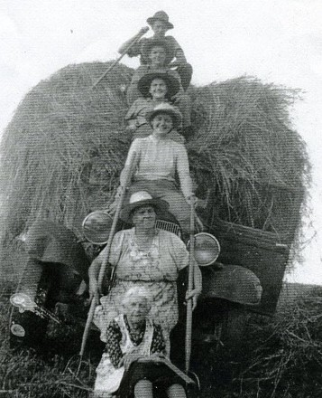

Things were less mechanized then. Henry McCauley still plowed with horses, and most tasks needed to be done by hand.

Dorothy went to Castlederg School, which was about two miles from the family farm. It was a one-room school. There were no school buses or other transportation, so the students walked to and from the school, even in winter. She was a good student and as she progressed through the grades, she helped the teacher with the younger students.

Like any child growing up on a farm, Dorothy helped with the chores. She milked cows and did other tasks around the farm. One of the chores for a year or two was to plant trees in a hillier section of the farm to create a source of wood and limit erosion.

Dorothy went to high school in Bolton.

After Dorothy finished high school, she and her sister Ruth went to secretarial school in Toronto. Dorothy stayed in Toronto, living with Ruth, and worked as a secretary. Dorothy and Ruth occasionally went to dances/socials for returning servicemen.

Dorothy and Harvey

Dorothy and Harvey met at one of the dance/socials for returning servicemen, probably sometime in 1945. Harvey was smitten with Dorothy. She let him know where she lived, and he used to come around to visit her. He would hang around while she did daily chores, like ironing, and kept asking her out. She eventually agreed to go out with him.

After they had been going out together for a while, Harvey asked Dorothy to marry him, and she said yes. Harvey and Dorothy had trouble finding a clergyman who would conduct a marriage ceremony for an inter-faith couple. Eventually they approached Rabbi Abraham Fineberg of the Holy Blossom Temple, probably Canada's most famous rabbi at the time, who agreed to marry them. They were married on December 6, 1945. Ruth and her new husband, Lorne Mashinter, a farmer from the Bolton area, were their witnesses.

Harvey and Dorothy continued to work and live in Toronto for a few years after getting married. At least for part of the time, they lived at 140 Heward Street. Dorothy became pregnant shortly after the wedding, but their first son Murray was born prematurely in August 1946 and survived less than a full day.

Dorothy remained close to her family, and Harvey and Dorothy would visit Dorothy's parents who still lived on and worked the family farm north of Bolton. Harvey had grown up in a city and knew little about life on a farm. The McCauley family were amused by his attempts to help around the farm.

Harvey and Dorothy moved to the Bolton area and Harvey opened a clothing store. In June 1948, Dorothy gave birth to a healthy baby boy, William Richard (Rick) Firestone, at Orangeville Hospital.

Firestone's Apparrel was not a roaring success, so Harvey and Dorothy decided to move to Montreal where Harvey would have greater job opportunities.

The move from Montreal to Bolton was in the winter of '51-'52; Rick has a vague memory of the move.

Harvey, Dorothy and Rick lived on Davaar Avenue in Outremont, only about 8 blocks “west” of De Le'Epee, where Harvey had once lived. Davaar was also close to Strathcona Academy, where Harvey attended high school before he had to drop out. Rick has some memories of living on Davaar, including deliveries of milk and bread by horse-drawn wagons.

Dorothy became pregnant again, and gave birth to Gary in May 1952. Harvey and Dorothy wanted a house of their own and bought one in Dorval, a western suburb of Montreal. There were problems with the house, and they had to move to an apartment on Mackenzie Street, in the Cote-des-Neiges area of Montreal. They were soon able to buy a new home at 5270 MacMahon Avenue in Notre-Dame-de-Grace, in the western part of the City of Montreal.

The home on MacMahon was half of a two-story semi-detached home. It was newly-built brick and stone structure. The main floor contained a living/dining room area, a kitchen, a small hall area, and a small powder room. Upstairs were three bedrooms and a bathroom. The basement contained a single-car garage (down a steep driveway), a laundry area and a small rec-room. Harvey built a train-track set-up in the rec room for Rick's electric train. The train tracks were attached to a peg-board that folded up against the wall.

The home was a little over a block from Cote-St-Luc shopping centre. Dorothy often walked home with two very full bags of grocery and her youngest son whiningly complaining about having to walk so far.

Dorothy's older cousin Lillian Robinson had married Charlie Rawson, a commercial artist and lived a short block away on St. Ignatius Avenue. Charlie died of a brain tumour. Lillian and Charlie had been friends with their neighbours the Fittons. After Mrs. Fitton died near the time of Charlie's death, and Lillian and Alan Fitton then married. Lillian and Charlie, and later Lillian and Alan, frequently socialized with Harvey and Dorothy.

At some point in the early 1950s, Harvey became the General Manager of Suitmaker, a company that made women's clothing. Its factory was located at 7095 Alexandra Street. The building had offices (administrative and design) on the first floor and production (cutting tables, sewing machines) on the second floor. Both Harvey's father and his brother Jack were also in the clothing business. Max was a clothing designer and cutter, and Jack, like Harvey, was a factory manager. Because of Harvey's involvement in the garment industry, the family got some of their clothing wholesale. Dorothy got some suits from Suitmaker, and Harvey and the boys got their clothes wholesale from Rothstein Brothers.

While Rick and Gary were young, Dorothy was a full-time mother and homemaker. Like her mother and sisters, she was an excellent baker, who made pies and cookies regularly, and always had hot meals for the family. Harvey worked long hours and did not help too much around the kitchen, but in nice weather barbecued meat outdoors.

Both Rick and Gary played hockey as boys, and Dorothy would attend all their games in the cold Montreal winter. She stood on the snow-banks that bordered the outdoor rink, getting colder and colder as the game went on. Dorothy hated the cold.

Dorothy was a volunteer fund-raiser for Red Feather (predecessor of United Way) and March of Dimes. She also washed the hair of some of her friends, and did temporary work as a census-taker.

The family had a succession of cars: an early- to mid-1950s Ford, a 1957 Chevrolet, a 1960 Chevrolet, and a 1963 (or so) Pontiac. The latter three were company cars, part of Harvey's compensation. Harvey bought Dorothy a car in the mid-1960s, so Dorothy wouldn't have to carry the groceries home and could go places without having to wait for a bus.

Although their home was in Montreal, Dorothy, Rick and Gary spent their summers in Bolton with Dorothy's mother. The entire family went to the McCauley Christmas dinners in Bolton.

Both boys attended Sir Arthur Currie School through Grade 7. Rick went to Monklands High School, and Gary went to Montreal West High School.

In 1964, Harvey, Dorothy, Rick and Gary took a two-week vacation in Britain. They rented a car (a blue Ford Cortina) and visited London, Oxford, York, Edinburgh, various castles in Scotland, Stonehenge, and Dover, among other places. Harvey had spent time in Britain during the war, but this was the first time across the Atlantic for Dorothy. They also took a side trip to Paris.

In the 60s, Harvey, Dorothy and the boys went to Norway to meet with some of the people who had helped Harvey and the other members of the crew escape. Maurice Neil, the crew's navigator and his wife also went. In addition to spending time with Harvey's friend Kjell Harmens and his family, they also spent a lot of time with Helen Mowinckel-Nilsen, one of the leaders of the effort to save the crew from capture. The main event was a celebratory dinner at which all 70+ people who had helped the crew were present.

Harvey was a member of the Royal Air Forces Escaping Society, whose members had served in various Commonwealth Air Forces and had crashed or otherwise ended up in Axis-controlled territory in World War II and either evaded or escaped capture and returned safely to Allied-controlled territory.

In the late 1960s, RAFES organized events, first bringing a group of people who had helped various members of RAFES escape, and then a tour of Europe by RAFES members and their families. Harvey was involved in the planning, and Dorothy also became very involved in organizing these events.

The RAFES became important an important part of Harvey's and Dorothy's lives. In addition to their efforts in organizing the events, Harvey and Dorothy became good friends with Canadian members of the RAFES, in particular Dick Garrity and his wife Maureen, and Red Banville and his wife Dallas. They also became friends with some of the European “helpers”, not only the Norwegians who had helped Harvey, but other helpers from France and Belgium.

In the late 60s, Harvey and Dorothy moved to 425 Ballantyne Avenue N., in Montreal West. By that time, Rick had graduated from high school in 1965. He stayed in Montreal for his first college year at McGill, but then dropped out and moved out of the home to travel and later to continue his education at Mackinac College and Brock University.

Nineteen sixty-seven was an eventful year. It was Canada's centennial, and the RAFES organized a visit to Canada for a number of helpers. Expo 67 opened in Montreal and ran through the summer. Dorothy enjoyed visiting the various pavilions at Expo 67.

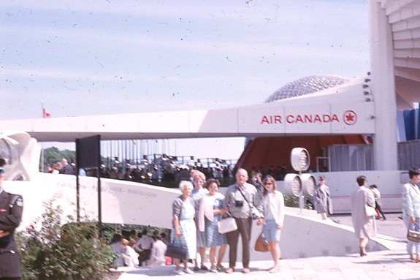
Ida McCauley, Dorothy, Jean and Bruce McCauley with their daughter Marlene
In front of the Air Canada Pavilion at Expo 67

Gary graduated from high school in 1969, but stayed at home, attending first Dawson College and then McGill, although he got an apartment near McGill. Dorothy returned to the work force when Gary was in high school. She worked as an assistance to an insurance broker, Ron Williams. The insurance office was in the basement of his family home in Westmount. After a few years, Dorothy was doing all the work.

Suitmaker was purchased by an American company, and in the late 1960s, the corporate parent decided to close Suitmaker. They offered Harvey a job at a plant in New Bedford, Massachusetts, but he declined, at least in part because he did not want to expose Gary to the American military draft.

Harvey eventually found work with Rubenstein Brothers, a company that sold equipment to clothing manufacturers. Harvey worked for them for several years before retiring.

Harvey and Dorothy wanted to be closer to Dorothy's family. They moved to Bolton, then back to Montreal for a while, then to Orangeville and finally back to Bolton. Harvey did some odd jobs with his brother-in-law, Bruce at Glen Eagle Golf Course. Dorothy and Harvey got to know some of their nieces and nephews as adults

For a period of time in the 1980s, Gary worked for Frontier Airlines, and Harvey and Dorothy had some air-travel benefits as a result. They took one trip to France with Gary and his wife Jane.

Gary attended law school in Tucson from 1984 to 1987, and Harvey and Dorothy loved to visit Arizona in the winter, renting their own apartment for months at a time. They continued to visit Arizona in winter for some time after Gary and Jane moved away.

After some time working in radio jobs, Rick joined the Canadian armed forces as a pilot. Harvey and Dorothy visited Rick and his wife Susan, and their growing family, in the various cities Rick was posted to.

Dorothy's health declined significantly in the 1990s. She was in substantial pain most of the time, but would try to put on a brave face for family. Harvey cared for her as well as he could.

For years, Rick and Gary had been asking Harvey and Dorothy to move to the west coast to be closer to their sons – Rick in Victoria BC and Gary in Oregon. They finally agreed and had started preparations to move, when Dorothy fell in their home in Bolton and was hospitalized. She never recovered fully and died without returning home.

After Dorothy's death, Harvey moved to Victoria, BC. In the fall of 2004, Harvey, his sons and granchildren visited Norway to meet with the two surviving helpers – Helen Mowinckel Nilsen and Kjell Harmens – and to revisit the site of the World War II emergency landing and escape from Nazi-occupied territory.

In Victoria, Harvey lived at The Shelbourne in a nice retirement apartment. He walked in the neighbourhood, borrowed and read books from the nearby library, went on outings with fellow residents and enjoyed socializing with them. When he first started living there, he said he felt younger than the rest of the residents, even though he wasn't. After a while, he felt more at home, and eventually become one of the older residents.

Over the years, Harvey's health deteriorated. His continued to suffer from the pain in his neck and knees from his wartime airplane crashes and emergency landings. He also started to suffer from Alzheimers. Eventually he was no longer able to stay at the Shelbourne, and moved to the Veterans Memorial Lodge at the Broadmead. He died on November 13, 2019.

Three of Harvey's grandparents were from Iasi, Romania. Harvey's paternal grandmother, Sophie Weinstock, was from Rexingen Germany. She was adopted by Jewish parents, but her birth parents may not have been Jewish.
St. Dominique is one block “east” (actually northeast) of Rue St. Laurent (the Main). Do not have the exact address.
Jeanne Mance is one block “east” of Park Avenue, and 5 blocks “west” of St. Dominique.
About half-way between Park Avenue and Blvd. St. Laurent.
They may also have lived elsewhere in the area.
Later in life, while serving in the RCAF, Harvey was known as “Red”. His brother Jack had the nickname “Retread” and Roz's nickname was “Shrimp”.
Guy-Drummond is currently a French-language elementary school, and the Strathcona Academy building is now used by the Université de Montréal.
There were three girls in the family, and we are not sure whether all three or just two of them lived with the Firestones.
And had even spent WWI in detention on St. Helen's Island.
Ida's name on her birth certificate was Ida Georgina Maud Steele, but she is also used the name Ida Mary Georgina Steele. Ida's parents and one of her grandmothers were born in Canada. Her other grandparents were born in Yorkshire. The Canadian-born grandmother's father was from Yorkshire and her mother was born in Ireland, to a Protestant (English, Dutch and French Huguenot) family. Most, if not all, of the Yorkshire ancestors were farmers.
Henry's father was born in Ireland (an Orangeman) and his mother was born in Canada to parents who were from the same general area in Yorkshire that Ida's ancestors were from.
Rabbi Fineberg was possibly the most famous rabbi ever in Canada. He was an advocate for a variety of liberal causes, advocating not just for Jews, but for Japanese-Canadians, black Canadians, and French-Canadians. He was with John Lennon for the recording of “Give Peace a Chance.”
They had married on October 6, 1945.
Monklands High School was closed in 1979 and converted into a residence for seniors. Montreal West High School is now known as Royal West Academy.

